Spring 2014 CS201 Homework 2
Due 02/01/2014 11:59 pm

Q1 (10 points)
For each positive integer n, let P(n) be the formula
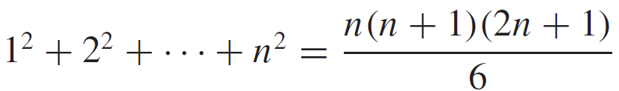

a. Write P(1). Is P(1) true?
b. Write P(k).
c. Write P(k + 1).
d. In a proof by mathematical induction that the formula holds for all integers n ≥ 1, what must be shown in the inductive step?

Q2 (10 points)
Use the formula for the sum of the first n integers and/or the formula for the sum of a geometric sequence to evaluate the sums or to write them in closed form.
a. 3 + 4 + 5 + 6+· · ·+1000
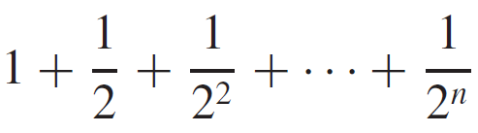
b.

Where n is a positive integer.

Q3 (50 points)
Prove each of the statements by mathematical induction.
a.
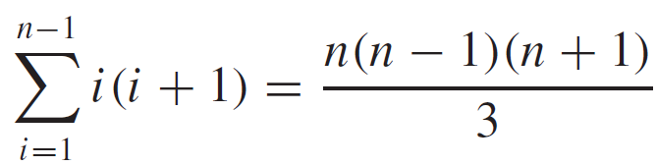

for all integers n ≥ 2.

b.
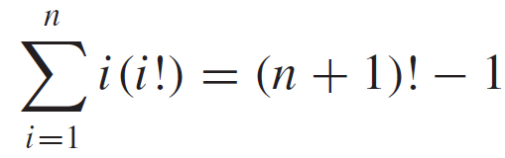
for all integers n ≥ 1.

c. If x is a real number not divisible by π, then for all integers n ≥ 1,
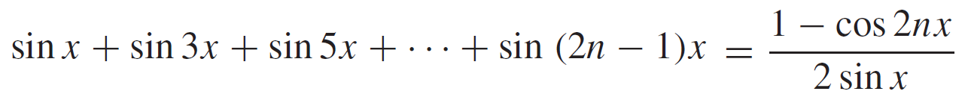

d. 3^{2n} - 1 is divisible by 8, for each integer n ≥ 0.

e. 2^{n} < (n + 1)!, for all integers n ≥ 2.

f. A sequence a₁, a₂, a₃, . . . is defined by letting a₁ = 3 and a_{k} = 7a_{k-1} for all integers k ≥ 2. Show that a_{n} = 3·7^{n-1} for all integers n ≥ 1.

Q4 (10 points)
find the mistakes in the “proof” by mathematical induction.
“Theorem:” For any integer n ≥ 1, all the numbers in a set of n numbers are equal to each other.
“Proof (by mathematical induction): It is obviously true that all the numbers in a set consisting of just one number are equal to each other, so the basis step is true. For the inductive step, let A = {a₁, a₂, . . . , a_{k} , a_{k+1}} be any set of k + 1 numbers. Form two subsets each of size k:
B = {a₁, a₂, a₃, . . . , a_{k} } and
C = {a₁, a₃, a₄, . . . , a_{k+1}}.
(B consists of all the numbers in A except a_{k+1}, and C consists of all the numbers in A except a₂.) By inductive hypothesis, all the numbers in B equal a₁ and all the numbers in C equal a₁ (since both sets have only k numbers). But every number in A is in B or C, so all the numbers in A equal a₁; hence all are equal to each other.”

